**Linear Search**

**Objective:**

To implement the Linear Search algorithm in C and analyze its time complexity.

**Theory:**

**Linear Search** is a simple searching algorithm that sequentially checks each element of an array until the desired element is found or the end of the array is reached.

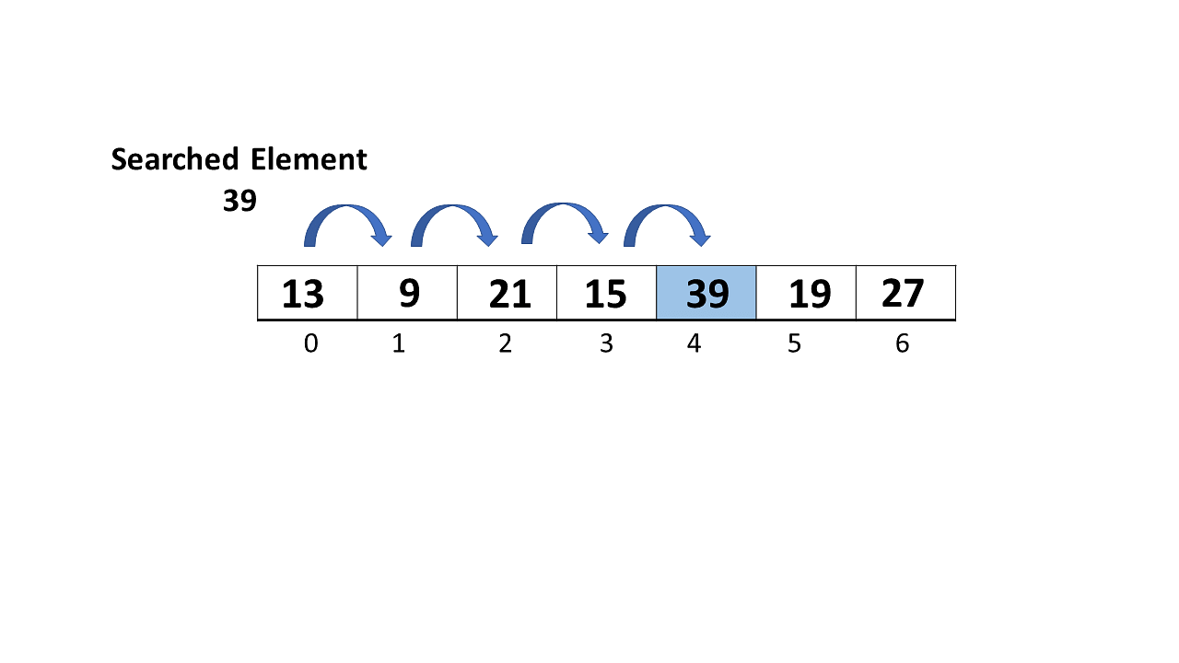

**Algorithm:**

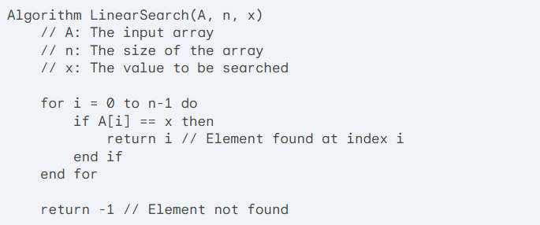

**C Implementation:**

C

#include <stdio.h>

int linearSearch(int arr[], int n, int x) {

for (int i = 0; i < n; i++) {

if (arr[i] == x) {

return i;

}

}

return -1;

}

int main() {

int arr[] = {2, 3, 4, 10, 40};

int x = 10;

int n = sizeof(arr) / sizeof(arr[0]);

int result

= linearSearch(arr, n, x);

if (result == -1)

printf("Element is not present in array\n");

else

printf("Element is present at index %d\n", result);

return 0;

}

**Analysis:**

**Time & Space Complexity:**

